How to Start Tomcat Automatically At The Startup and Reboot of The Instance.
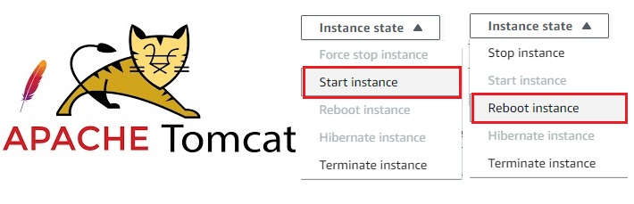
Observation.
If you have installed Tomcat By downloading Binaryfile,Then you might have observed that Tomcat will not start after stop and start or reboot of your server.
Execute the following commands to Enable-Tomcat on reboot and startup of your instance.
# Become a root user.
sudo su -

# Download java.
amazon-linux-extras install java-openjdk11=latest -y

# Check java version
java --version

# Change directory to opt.
cd /opt

# Download the tomcat binary file.
wget https://dlcdn.apache.org/tomcat/tomcat-10/v10.1.9/bin/apache-tomcat-10.1.9.tar.gz

# Extract the file.
tar -xvzf apache-tomcat-10.1.9.tar.gz

# Rename the file.
mv apache-tomcat-10.1.9 tomcat

# Change directory to /etc/init.d
cd /etc/init.d

# Create a file name tomcat.
vi tomcat

# Past the below content.
--------------------------------------------------------------------------------------------------------------------------------
#!/bin/bash
# description: Tomcat Start Stop Restart
# process-name: tomcat
# chkconfig: 234 20 80
CATALINA_HOME=/opt/tomcat
case $1 in
start)
sh $CATALINA_HOME/bin/startup.sh
;;
stop)
sh $CATALINA_HOME/bin/shutdown.sh
;;
restart)
sh $CATALINA_HOME/bin/shutdown.sh
sh $CATALINA_HOME/bin/startup.sh
;;
esac
exit 0
-------------------------------------------------------------------------------------------------------------------------------

# Now give Execute permissions to tomcat file.
chmod +x tomcat

# Adds the "tomcat" service to the system's startup configuration.
chkconfig --add tomcat

# Configuring the "tomcat" service to start automatically at runlevels 2, 3, and 4.
chkconfig --level 234 tomcat on

# Start the tomcat.
service tomcat start

#Sets the "tomcat" service to start automatically when the system boots up.
chkconfig tomcat on

You Have Successfully Enabled Tomcat on reboot and startup of your instance.
Note:-
- In this Post i have focused on only Enabling The Tomcat on reboot and startup of your instance.
- Creation of tomcat users and assigning roles to them and some best practices were discussed in my previous post.
- You can check it here. https://gist.github.com/sampathshivakumar/d46e0bd855648cdaaba68a87c75a10cc
Thank you for reading this post! I

